1. Breadth First Search (BFS)
Aim: To implement Breadth First Search using Python.
Algorithm:
- Start from the initial node.
- Add the node to the queue.
- Remove the first node from the queue.
- Visit the node and print it.
- Add its unvisited neighboring nodes to the queue.
- Repeat until the queue is empty.
Output:
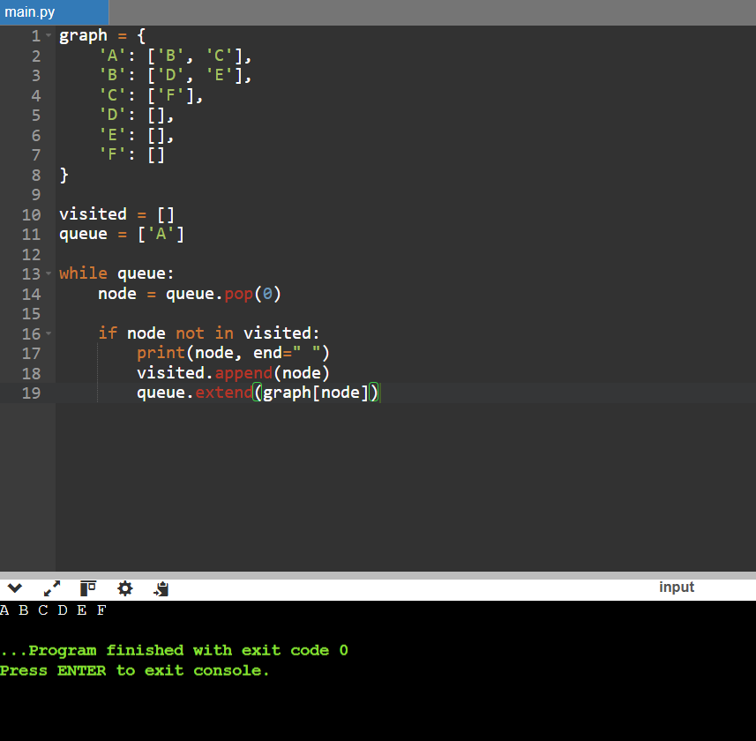
Result: Thus, the Breadth First Search algorithm was implemented successfully using Python.

2. Depth First Search (DFS)
Aim: To implement Depth First Search using Python.
Algorithm:
- Start from the initial node.
- Mark the node as visited.
- Print the node.
- Visit each unvisited neighboring node recursively.
- Continue until all reachable nodes are visited.
Output:
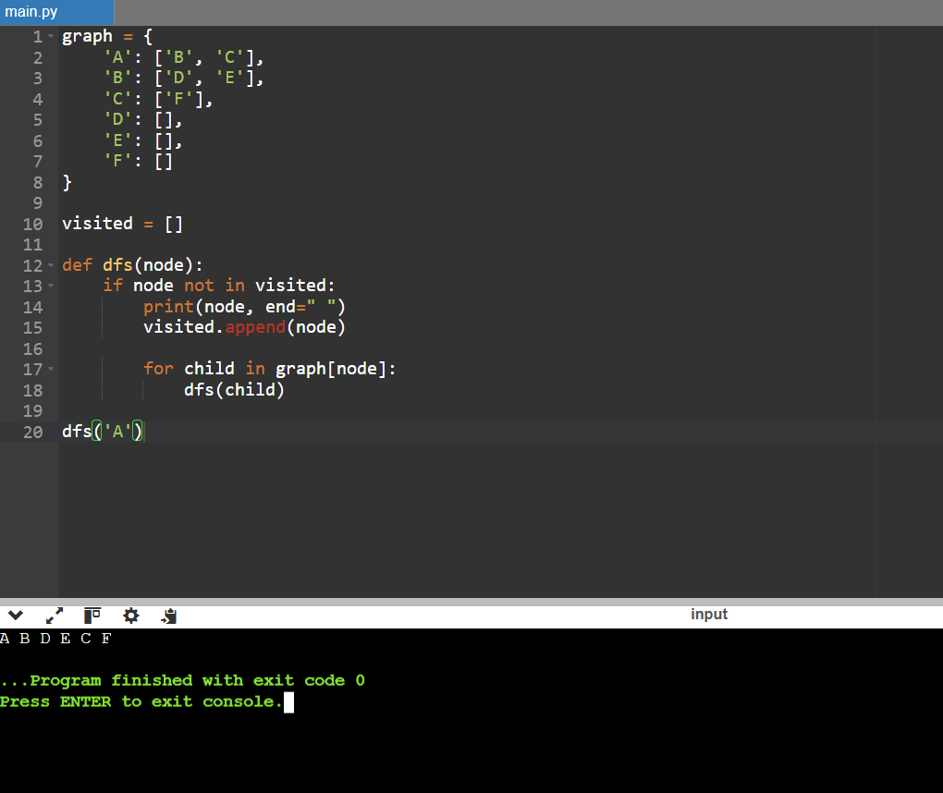
Result: Thus, the Depth First Search algorithm was implemented successfully using Python.

3. Water Jug Problem
Aim: To solve the Water Jug Problem using Python.
Algorithm:
- Initialize two jugs with zero water.
- Define the capacities of both jugs.
- Generate possible states by filling, emptying, and transferring water.
- Store visited states to avoid repetition.
- Check whether the goal amount is reached.
- Stop when the goal state is found.
Output:
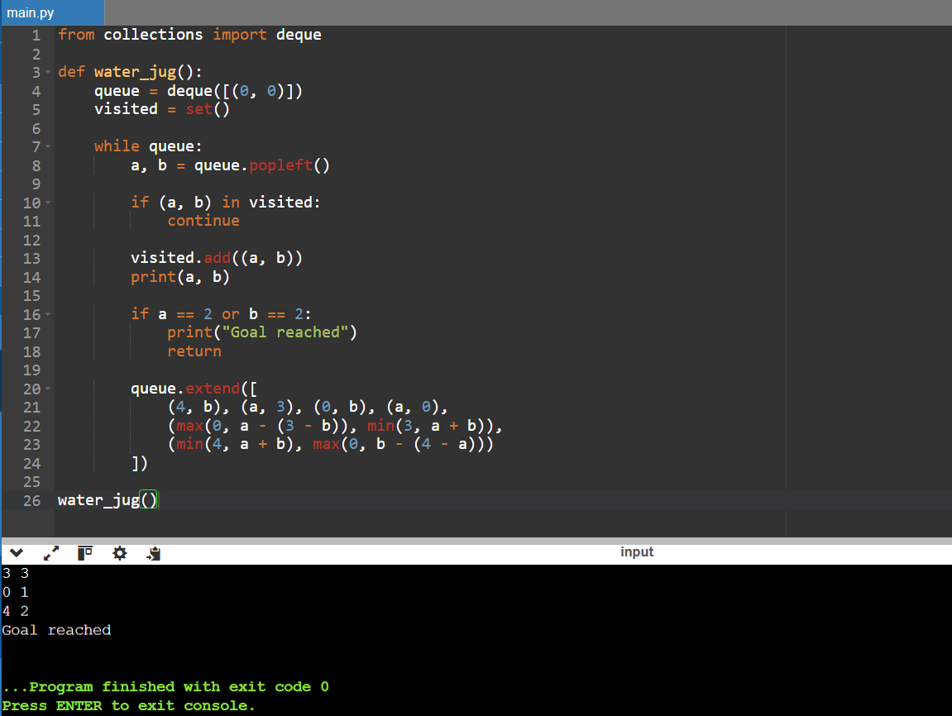
Result: Thus, the Water Jug Problem was implemented using Python.

4. A* Search Algorithm
Aim: To implement the A* Search algorithm using Python.
Algorithm:
- Initialize the start node.
- Calculate the evaluation function \(f(n)=g(n)+h(n)\).
- Select the node with the lowest evaluation value.
- Check whether the selected node is the goal.
- Calculate costs for neighboring nodes.
- Repeat until the goal is reached.
Output:
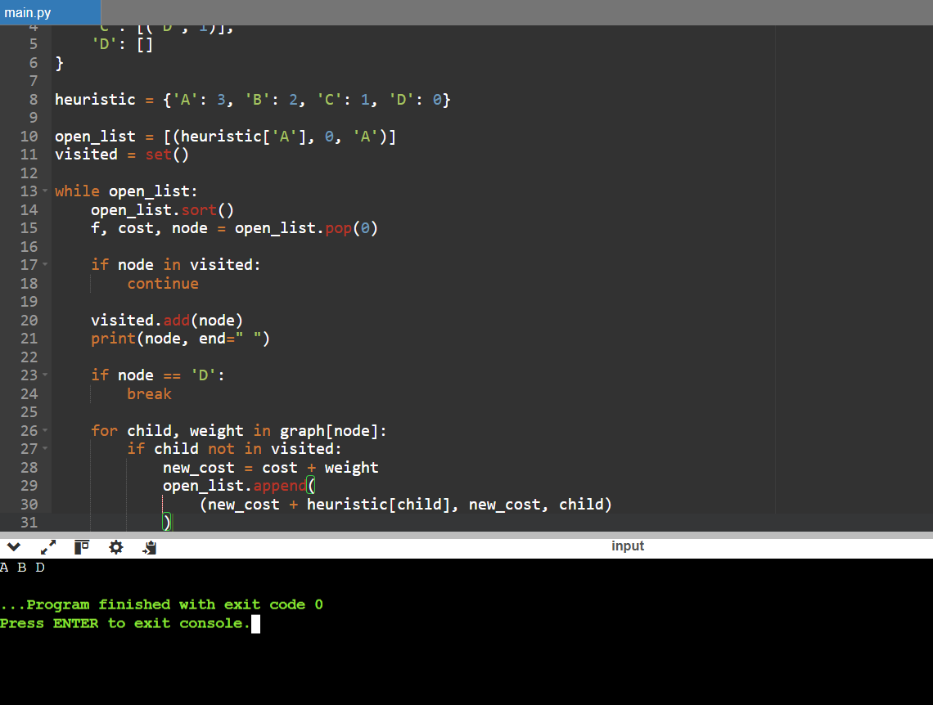
Result: Thus, the A* Search algorithm was implemented successfully using Python.

5. Hill Climbing
Aim: To implement the Hill Climbing algorithm using Python.
Algorithm:
- Initialize the current state.
- Check the neighboring state's value.
- Move to the neighbor if its value is greater.
- Repeat until no better neighbor is available.
- Display the final value.
Output:
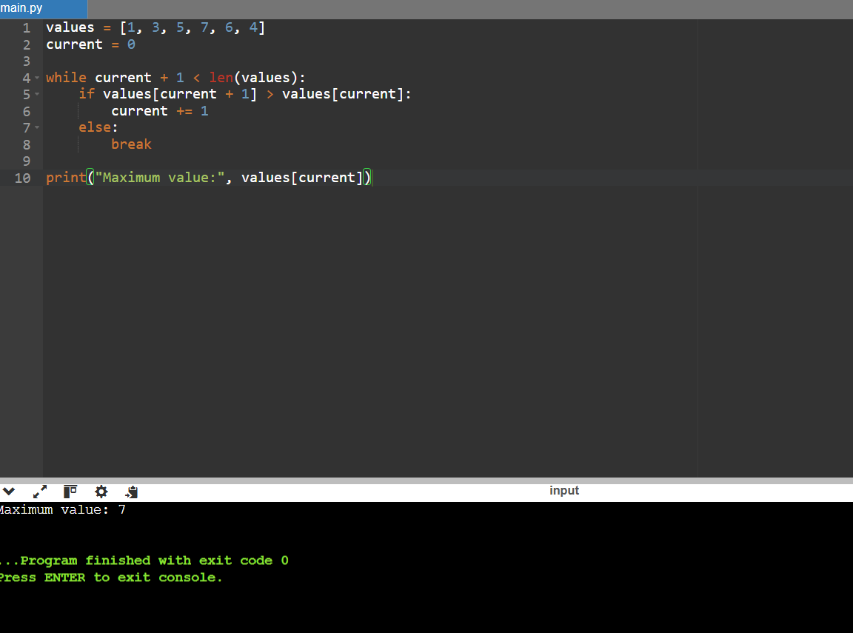
Result: Thus, the Hill Climbing algorithm was implemented successfully using Python.

6. Tic-Tac-Toe Board
Aim: To create and display a Tic-Tac-Toe board using Python.
Algorithm:
- Create a list containing nine empty spaces.
- Assign symbols X and O to selected positions.
- Divide the list into three rows.
- Display the board.
- Stop the program.
Output:
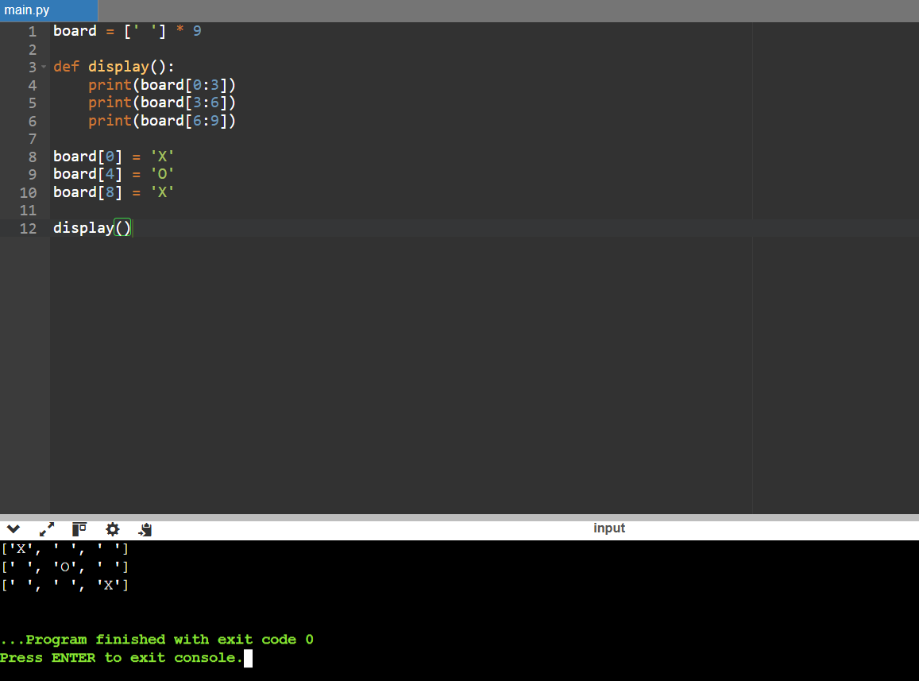
Result: Thus, a Tic-Tac-Toe board was created and displayed using Python.

7. N-Queens Problem
Aim: To solve the N-Queens Problem using the backtracking technique in Python.
Algorithm:
- Initialize an empty chessboard.
- Place a queen in a column of the current row.
- Check whether the position is safe.
- If safe, move to the next row.
- If no safe position exists, backtrack.
- Repeat until all queens are placed.
Output:
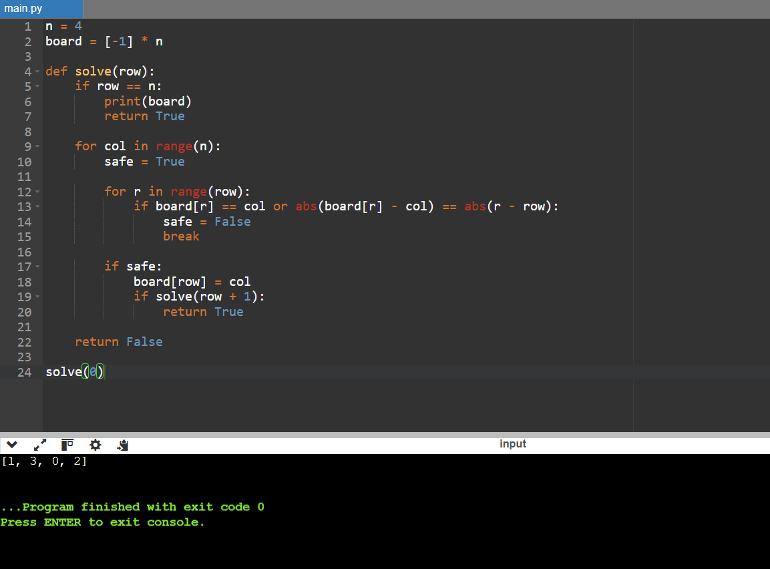
Result: Thus, the N-Queens Problem was solved using Python backtracking.

8. Missionaries and Cannibals
Aim: To solve the Missionaries and Cannibals Problem using Python.
Algorithm:
- Initialize three missionaries and three cannibals on one riverbank.
- Represent each state using the numbers on the first bank and boat position.
- Generate possible boat movements.
- Check that the missionaries are never outnumbered by cannibals where missionaries are present.
- Avoid revisiting states.
- Continue until everyone reaches the opposite bank.
Output:
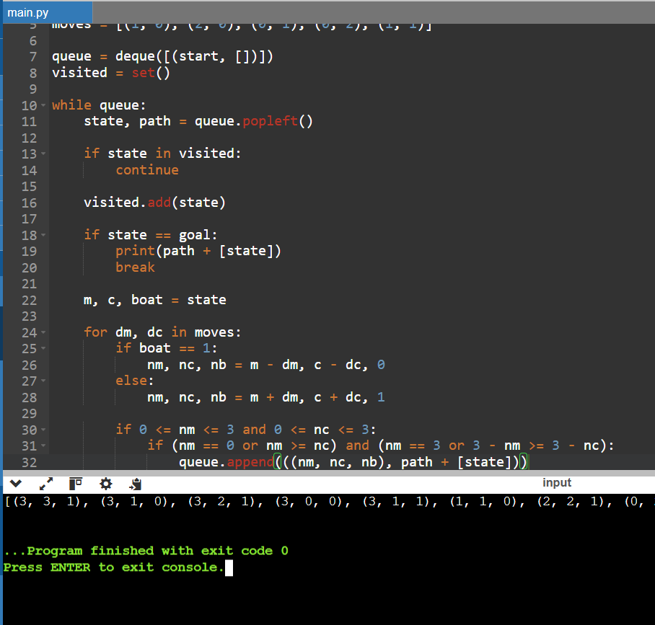
Result: Thus, the Missionaries and Cannibals Problem was implemented using Python.

9. Fibonacci Series Using Recursion
Aim: To generate the Fibonacci series using recursion in Python.
Algorithm:
- Define a recursive Fibonacci function.
- Return \(n\) when \(n\) is 0 or 1.
- Otherwise, calculate the sum of the previous two Fibonacci numbers.
- Read the number of terms.
- Display the series.
Output:
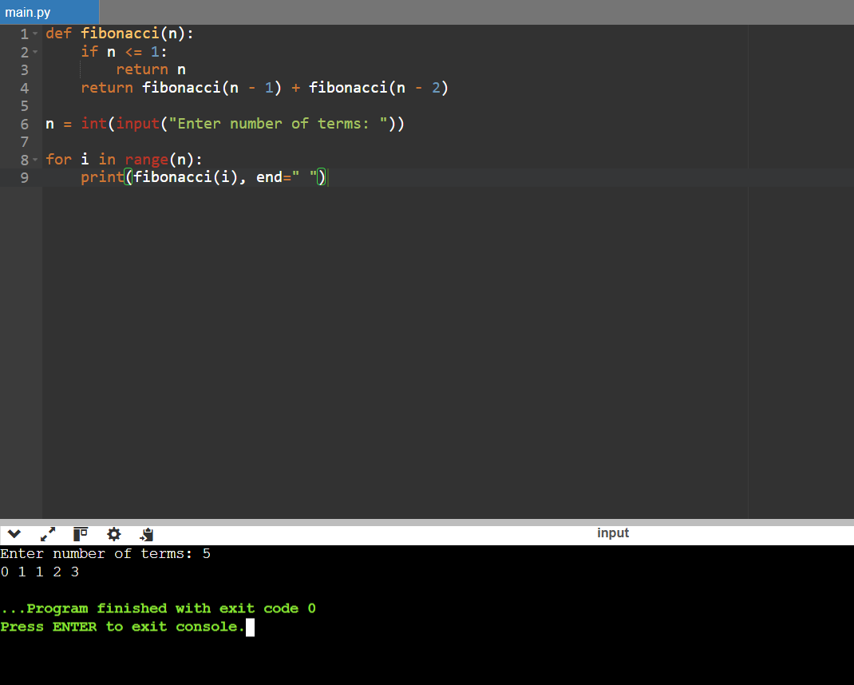
Result: Thus, the Fibonacci series was generated successfully using Python recursion.

10. Count the Number of Vowels
Aim: To count the number of vowels in a string using Python.
Algorithm:
- Read a string from the user.
- Convert the string to lowercase.
- Initialize the vowel count to zero.
- Check each character for the vowels a, e, i, o, and u.
- Increase the count whenever a vowel is found.
- Display the total count.
Output:
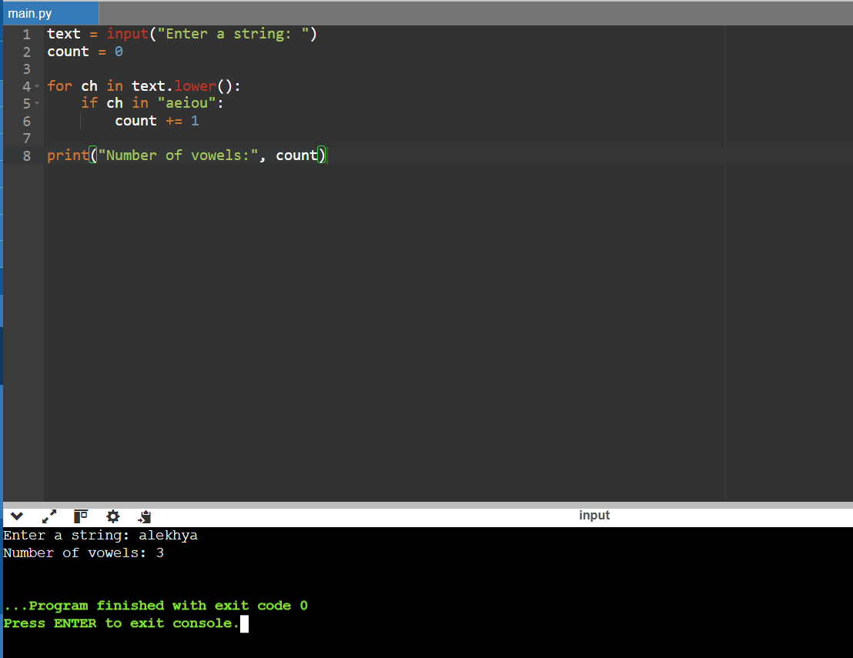
Result: Thus, the number of vowels in a string was counted successfully using Python.

11. Best First Search
Aim: To implement Best First Search using Python.
Algorithm:
- Initialize the starting node.
- Store the nodes in a list.
- Select the next node according to the search priority.
- Mark the selected node as visited.
- Add its neighboring nodes.
- Repeat until the search is complete.
Output:
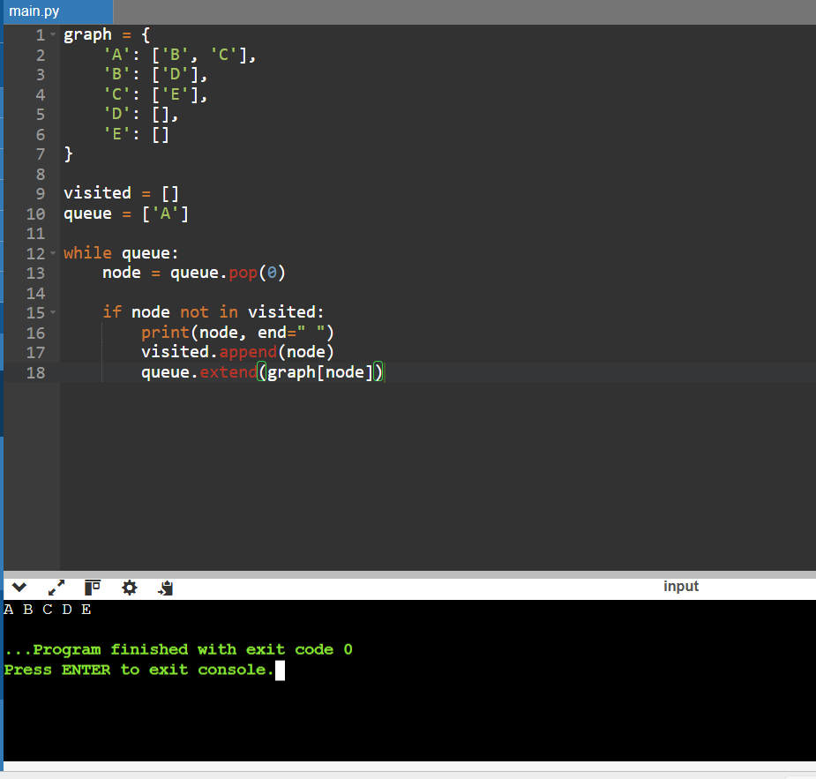
Result: Thus, a basic graph traversal program was implemented using Python. Note that the earlier code provided uses a FIFO queue, so it demonstrates BFS rather than heuristic-based Best First Search.

12. Simple Chatbot
Aim: To develop a simple rule-based chatbot using Python.
Algorithm:
- Read a message from the user.
- Convert the message to lowercase.
- Compare it with predefined messages.
- Display the corresponding response.
- If the message is unknown, display a default response.
- Stop when the user enters “bye”.
Output:
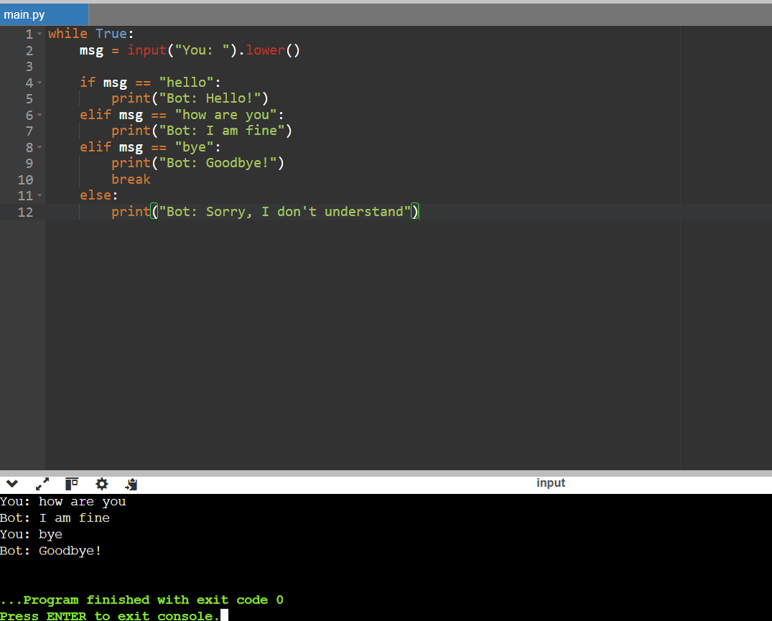
Result: Thus, a simple rule-based chatbot was developed using Python.

13. Factorial Using Recursion
Aim: To find the factorial of a number using recursion in Python.
Algorithm:
- Read a number from the user.
- Define a recursive factorial function.
- Return 1 if the number is 0 or 1.
- Otherwise, multiply the number by the factorial of the previous number.
- Display the result.
Output:
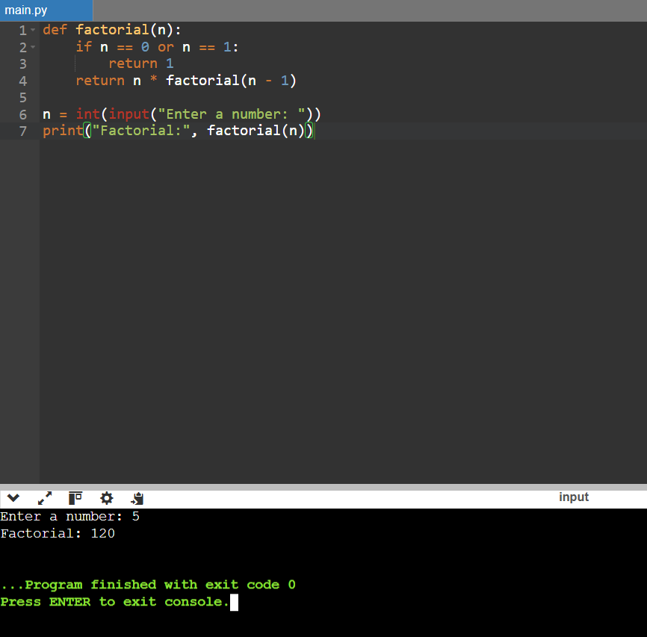
Result: Thus, the factorial of a number was calculated successfully using Python recursion.

14. Prime Number Check
Aim: To check whether a given number is prime using Python.
Algorithm:
- Read a number from the user.
- If the number is less than 2, classify it as not prime.
- Check divisibility by integers starting from 2.
- If any integer divides it exactly, classify it as not prime.
- Otherwise, classify it as prime.
- Display the result.

Output:
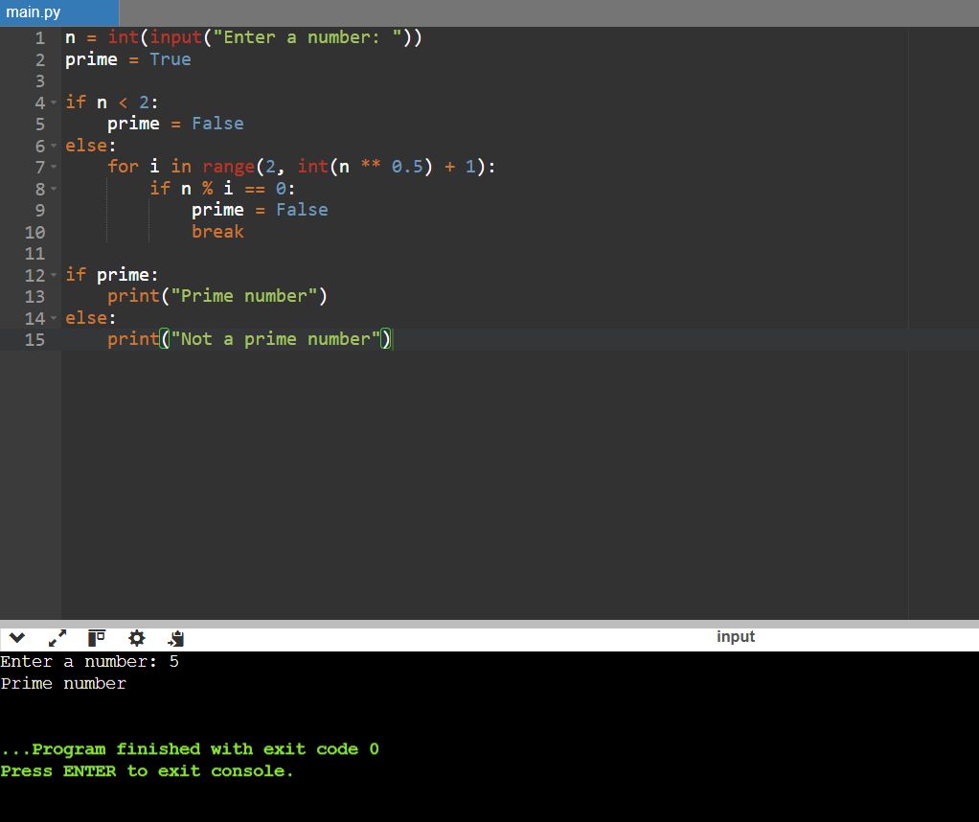
Result: Thus, the program successfully checks whether a number is prime.

15. Dijkstra's Shortest Path Algorithm
Aim: To find the shortest distances from a source node using Dijkstra's algorithm in Python.
Algorithm:
- Initialize the source distance to zero and all other distances to infinity.
- Select the unvisited node with the smallest distance.
- Update the distances of its neighboring nodes.
- Mark the selected node as visited.
- Repeat until all reachable nodes are processed.
- Display the shortest distances.

Output:
